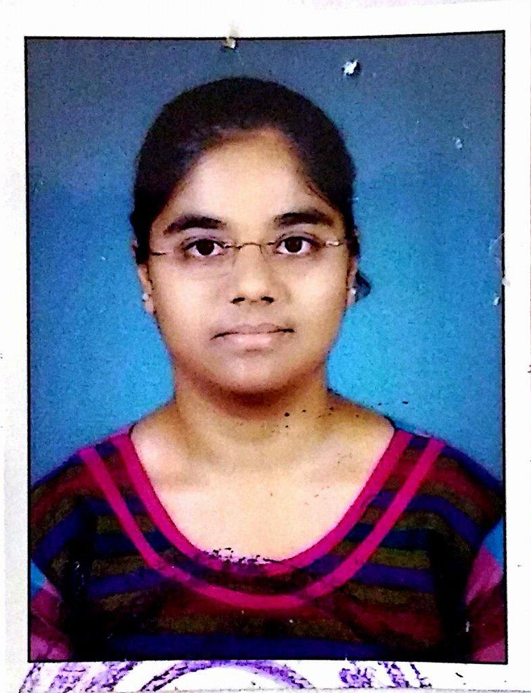
SHIVANI DESHMUKH
Contact no.: 7385182493
Email-Id: deshmukhshivanis@gmail.com

CAREER OBJECTIVE:

To work hard with full dedication for the achievement of organization objective under satisfying job contact, hence enhancing my skills and knowledge and ready to learn new things.

ACADEMIC PROFILE:

Course | Name of School / College | Board / University | Passing Year | Percentage
B.E. Computer | Babasaheb Naik College of Engg, Pusad | Amravati University | 2017 | 77.34
H.S.C. | P.N. Jr. College, Pusad | Amravati Board | 2013 | 79.33
S.S.C. | K. D. High School, Pusad | Amravati Board | 2011 | 85.64

TECHNICAL SKILLS:

- Primary Skills: | JAVA, SQL, J2EE, C, JDBC
- Tools:  - Server: | Eclipse  Apache Tomcat 7.0
- Databases: | MySQL, Oracle

CERTIFICATION:

- "AMCAT TOPPER" for the quarter of (1st November 2017- 31st January 2018).

CO-CURRICULAR ACTIVITIES:

- Participated in Paper Presentation in Threshold-2015
- Participated in Project Competition in Gaiety-2015
- Volunteer in various Programs organized at college level
PROJECT UNDERTAKEN:

PROJECT-NAME : ONLINE RESERVATION SYSTEM
TECHNOLOGY : JAVA
FRONT-END : HTML/CSS
BACK-END : MySQL
SUMMARY : WEBSITE FOR ONLINE TRAVEL AND MOVIE SEAT
BOOKING PURPOSE
SOFT SKILLS:
- Hardworking and Confident.
- Quick Learner.

PERSONAL PROFILE:

- Name : Shivani Sureshrao Deshmukh.
- DOB : 01-06-1995
- Languages Known : English, Hindi and Marathi.
- Local Address : Pimple Gurav, Pune.
- Permanent Address : Talao-lay-out, Pusad. Dist.Yavatmal(MH)

DECLARATION:

I hereby declare that the above information is true to the best of my knowledge and belief.

PLACE: Pune
DATE:
(SHIVANI DESHMUKH)

